1. Oauth 2 is authorization framework.
2. There are different authorization flows for different applications.
3. Before writing java code, you need to understand
   1. How authorization flow works.
   2. How to get an access token?
4. When you have better understanding about the concept, then we will see how to build your own Authorization Server.  
   We will also create a very simple Spring Boot app acting as resource server.
5. 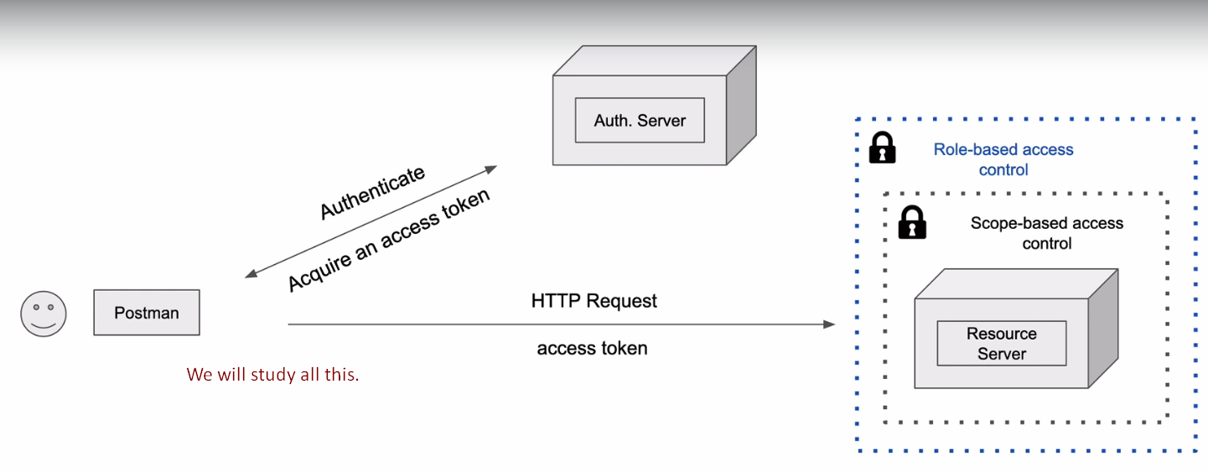
6. 